For use from September 2014/January 2015
Sciences guide

Sciences guide
For use from September 2014/January 2015

Middle Years Programme
Sciences guide
MYP320
Published May 2014
Updated July 2014
Published on behalf of the International Baccalaureate Organization, a not-for-profit
educational foundation of 15 Route des Morillons, 1218 Le Grand-Saconnex, Geneva,
Switzerland by the
International Baccalaureate Organization (UK) Ltd
Peterson House, Malthouse Avenue, Cardiff Gate
Cardiff, Wales CF23 8GL
United Kingdom
Website: www.ibo.org
© International Baccalaureate Organization 2014
The International Baccalaureate Organization (known as the IB) offers four high-quality and challenging educational programmes for a worldwide community of schools, aiming to create a better, more peaceful world. This publication is one of a range of materials produced to support these programmes.
The IB may use a variety of sources in its work and checks information to verify accuracy and authenticity, particularly when using community-based knowledge sources such as Wikipedia. The IB respects the principles of intellectual property and makes strenuous efforts to identify and obtain permission before publication from rights holders of all copyright material used. The IB is grateful for permissions received for material used in this publication and will be pleased to correct any errors or omissions at the earliest opportunity.
All rights reserved. No part of this publication may be reproduced, stored in a retrieval system, or transmitted, in any form or by any means, without the prior written permission of the IB, or as expressly permitted by law or by the IB’s own rules and policy. See http://www.ibo.org/copyright.
IB merchandise and publications can be purchased through the IB store at http://store.ibo.org.
Email: sales@ibo.org
International Baccalaureate, Baccalauréat International and Bachillerato Internacional
are registered trademarks of the International Baccalaureate Organization.

IB mission statement
The International Baccalaureate aims to develop inquiring, knowledgeable and caring young people who help to create a better and more peaceful world through intercultural understanding and respect.
To this end the organization works with schools, governments and international organizations to develop challenging programmes of international education and rigorous assessment.
These programmes encourage students across the world to become active, compassionate and lifelong learners who understand that other people, with their differences, can also be right.

IB learner profile

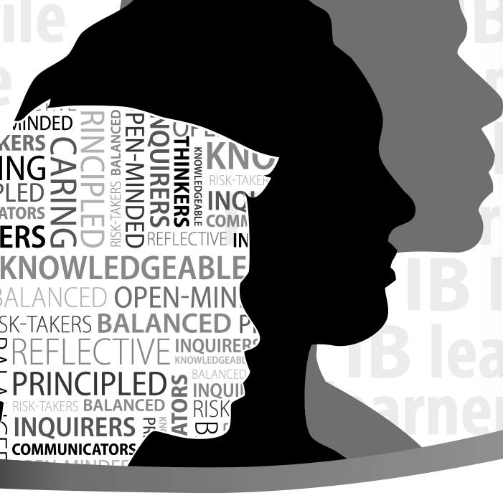
MINDED KERS nz
ING>Q
LED )₁⁻12
zm
ERSmo
E⁻¹
gSmEIK to
_{rf2mr7.1} r_{c6,}, F2I_Sf-TAKEr,
?"¹³ Ujj: 1194_
EE L.) REFLECTIVE IN
KNOWLEDGEABLE
- ALANCED OPEN-MIN
SK-TAKERS BALANCED P
REFLECTIVE '19,1T'
:PRINCIPLEN21/N6^{N}611⁾
^{l CE}_{u_} ^{D} RISK
INQUIRERSA ; _{o 0}

COMMUNICATORS
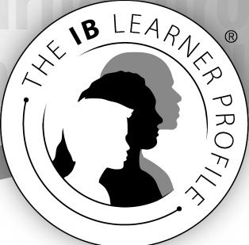

The aim of all IB programmes is to develop internationally minded people who, recognizing their
common humanity and shared guardianship of the planet, help to create a better and more peaceful world.
As IB learners we strive to be:

INQUIRERS
We nurture our curiosity, developing skills for inquiry and research. We know how to learn independently and with others. We learn with enthusiasm and sustain our love of learning throughout life.
KNOWLEDGEABLE
We develop and use conceptual understanding, exploring knowledge across a range of disciplines. We engage with issues and ideas that have local and global significance.
THINKERS
We use critical and creative thinking skills to analyse and take responsible action on complex problems. We exercise initiative in making reasoned, ethical decisions.
COMMUNICATORS
We express ourselves confidently and creatively in more than one language and in many ways. We collaborate effectively, listening carefully to the perspectives of other individuals and groups.
PRINCIPLED
We act with integrity and honesty, with a strong sense of fairness and justice, and with respect for the dignity and rights of people everywhere. We take responsibility for our actions and their consequences.
OPEN-MINDED
We critically appreciate our own cultures and personal histories, as well as the values and traditions of others. We seek and evaluate a range of points of view, and we are willing to grow from the experience.
CARING
We show empathy, compassion and respect. We have a commitment to service, and we act to make a positive difference in the lives of others and in the world around us.
RISK-TAKERS
We approach uncertainty with forethought and determination; we work independently and cooperatively to explore new ideas and innovative strategies. We are resourceful and resilient in the face of challenges and change.
BALANCED
We understand the importance of balancing different aspects of our lives—intellectual, physical, and emotional—to achieve well-being for ourselves and others. We recognize our interdependence with other people and with the world in which we live.
REFLECTIVE
We thoughtfully consider the world and our own ideas and experience. We work to understand our strengths and weaknesses in order to support our learning and personal development.

The IB learner profile represents 10 attributes valued by IB World Schools. We believe these attributes, and others like
them, can help individuals and groups become responsible members of local, national and global communities.
 | International Baccalaureate'  Baccalaureat International  Bachillerato Internacional |  | © International Baccalaureate Organization 2013  International Baccalaureate® I Baccalaureat International® I Bachillerato Internacional'

Introduction 1
Contents
Purpose of this guide 1
Sciences in the MYP 2
Programme model 2
Nature of sciences 4
Sciences across the IB continuum 5
Aims 8
Objectives 9
Planning a progression of learning 12
Interdisciplinary learning 15
MYP projects 16
Written and taught curriculum 17
Requirements 17
Planning the sciences curriculum 18
Teaching and learning through inquiry 19
Subject-specific guidance 26
Assessed curriculum 29
Alignment of objectives and criteria 29
Assessment criteria overview 30
Sciences assessment criteria: Year 1 31
Sciences assessment criteria: Year 3 36
Sciences assessment criteria: Year 5 42
eAssessment 48
Appendices 49
Related concepts in sciences 49
Sciences glossary 51
MYP command terms for sciences 53
Selected reading 55
Sciences guide

Introduction
Sciences guide 1
This guide is for use from September 2014 or January 2015, depending on the start of the school year.

Purpose of this guide
This document provides the framework for teaching and learning in sciences in the Middle Years Programme (MYP) and must be read and used in conjunction with the document MYP: From principles into practice (May 2014), which includes:
- general information about the programme
- the MYP unit planner, with guidance for developing the curriculum that is relevant for all subject groups
- detailed information about approaches to learning
- advice that supports access and inclusion (including accommodations for students with learning support requirements)
- a statement on academic honesty.
In MYP publications, requirements appear in a text box like this one.
Additional resources
Teacher support materials (TSM) are available in the online curriculum centre (http://occ.ibo.org). The TSM for sciences contains support for developing the written, taught and assessed curriculum. It provides examples of good practice, including subject group overviews, assessment tasks and markschemes, as well as student work with teacher comments.
An optional process of external assessment can lead to IB MYP course results for sciences courses, and these results can contribute to the awarding of an IB MYP certificate. More information is available in the annual publication Handbook of procedures for the Middle Years Programme.
A range of publications that support the MYP are available at the IB store (http://store.ibo.org).
Acknowledgments
The IB gratefully acknowledges the generous contributions of IB World Schools and a global community of educators who collaborate in the development of the Middle Years Programme.

Sciences in the MYP
2 Sciences guide
Figure 1

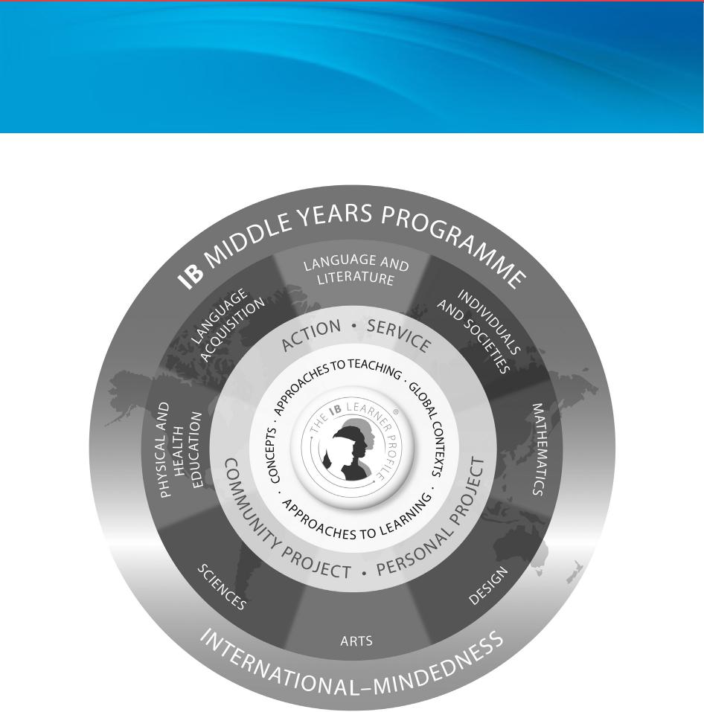
Programme model
Middle Years Programme model
The MYP is designed for students aged 11 to 16. It provides a framework of learning that encourages students to become creative, critical and reflective thinkers. The MYP emphasizes intellectual challenge, encouraging students to make connections between their studies in traditional subjects and the real world. It fosters the development of skills for communication, intercultural understanding and global engagement—essential qualities for young people who are becoming global leaders.
The MYP is flexible enough to accommodate the demands of most national or local curriculums. It builds upon the knowledge, skills and attitudes developed in the IB Primary Years Programme (PYP) and prepares students to meet the academic challenges of the IB Diploma Programme (DP) and the IB Career-related Certificate (IBCC).
The MYP:
- addresses holistically students’ intellectual, social, emotional and physical well-being
- provides students opportunities to develop the knowledge, attitudes and skills they need in order to manage complexity, and take responsible action for the future

Programme model
Sciences guide 3
- ensures breadth and depth of understanding through study in eight subject groups
- requires the study of at least two languages to support students in understanding their own cultures and those of others
- empowers students to participate in service with the community
- helps to prepare students for further education, the workplace and a lifetime of learning.

Sciences in the MYP
4 Sciences guide
The scientific mind does not so much provide the right answers as asks the right questions.

Nature of sciences
Claude Lévi-Strauss
With inquiry at the core, the MYP sciences framework aims to guide students to independently and collaboratively investigate issues through research, observation and experimentation. The MYP sciences curriculum must explore the connections between science and everyday life. As they investigate real examples of science applications, students will discover the tensions and dependencies between science and morality, ethics, culture, economics, politics, and the environment.
Scientific inquiry also fosters critical and creative thinking about research and design, as well as the identification of assumptions and alternative explanations. Students should learn to appreciate and respect the ideas of others, gain good ethical-reasoning skills and further develop their sense of responsibility as members of local and global communities.
Learning science involves more than simply learning technical terminology. The MYP considers all teachers to be language teachers and, thus, MYP sciences should enable students to access, use and communicate scientific knowledge correctly and confidently in oral, written and visual modes.

Sciences in the MYP
Sciences guide 5
The IB continuum of international education provides a progression of learning for students aged 3–19. In the PYP, science is viewed as the exploration of aspects of the natural world. Science within the IB programmes encourages inquiry, curiosity and ingenuity. Learners should develop an understanding of the resources of a rapidly-changing scientific and technological society and how to use those resources wisely. The MYP sciences curriculum aims to build on what students learn and do in the PYP and other student-centred programmes of primary education. There are no prior formal learning requirements.

Sciences across the IB continuum
The main approach to teaching and learning sciences is through structured inquiry in the context of interdisciplinary units. Students are encouraged to investigate science by formulating their own questions and finding answers to those questions, including through research and experimentation.
Scientific inquiry enables students to develop a way of thinking and a set of skills and processes that they can use to confidently tackle the internal assessment component of DP subjects in biology, chemistry and physics. Moreover, the MYP sciences objectives and assessment criteria A–D are aligned with the DP sciences objectives and internal assessment criteria, supporting the smooth transition from the MYP to the DP (see figures 2 and 3).
All IB programmes share common beliefs and values about teaching and learning science:
- International dimension: Students develop an appreciation that science requires open-mindedness and freedom of thought transcending gender, political, cultural, linguistic, national and religious boundaries.
- Aesthetic dimension: Students engage with the complexities, intricacies and beauty of science, which arouses their curiosity and heightens their learning.
- Ethical dimension: Students reflect on the ethical, social, economic, political, cultural and environmental implications of using science to solve specific problems. Students develop a personal, ethical stance on science-related issues.
- Learning through investigation: Students construct meaning by designing, conducting and reflecting on scientific investigations. The scientific process, which encourages hands-on experience, inquiry, and critical thinking, enables students to make informed and responsible decisions, not only in science but also in other areas of life.
- Collaboration: Students are provided opportunities to work individually and with their peers to learn about science within and beyond the classroom. They develop safe and responsible working habits in practical science.
The IB learner profile provides a strong foundation for teaching and learning science in IB programmes and is integral to its successful application.

Sciences across the IB continuum
Figure 2

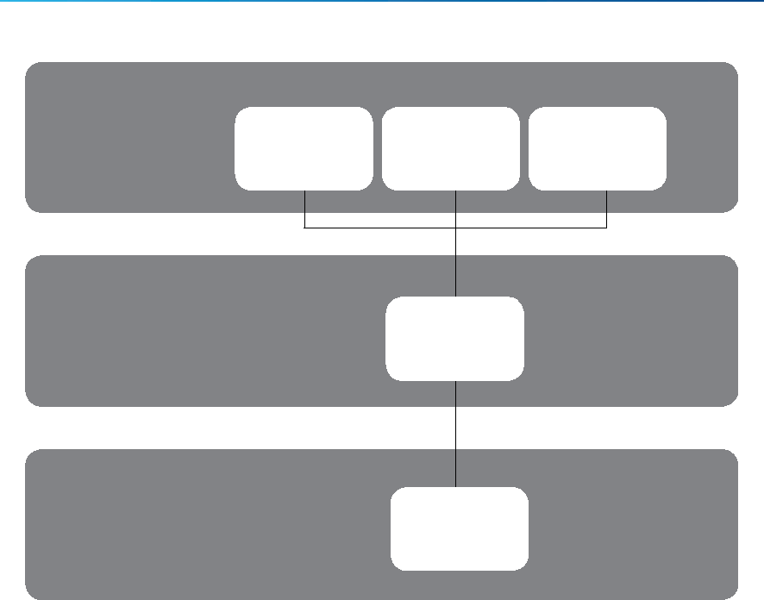
Primary Years Programme
Middle Years Programme
Diploma
Programme
Biology Chemistry Physics
Sciences
Science
IB continuum pathway to Diploma Programme subjects—biology, chemistry and physics
Figure 3

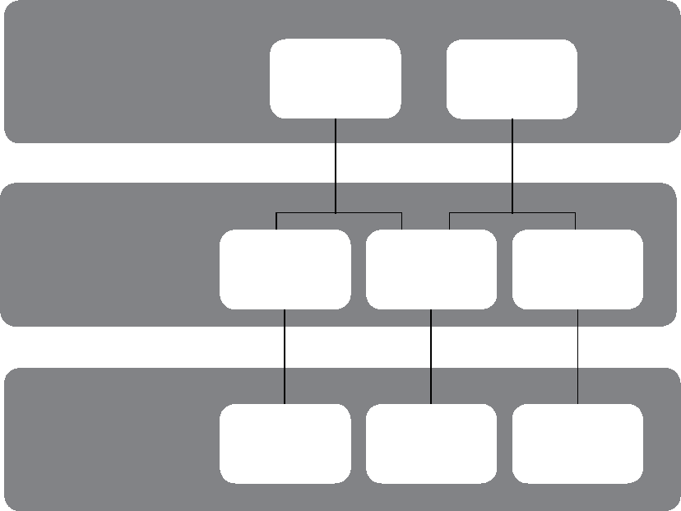
Primary Years Programme
Middle Years Programme
Diploma
Programme
Individuals and Sciences
societies
Social studies Science
Environmental
systems and
societies
Sports, exercise
and health
science
Personal, social
and physical
education
Physical
and health
education
IB continuum pathway to Diploma Programme subjects—sports, exercise and health science
and environmental systems and societies

6 Sciences guide

Sciences across the IB continuum
Sciences guide 7
MYP sciences also helps to prepare students for overall success in the IB Diploma Programme.
The knowledge, skills and attitudes that students develop in sciences courses provide a meaningful foundation for further study and help to prepare students for careers in academic and corporate research, as laboratory assistants and managers, in scientific consultancy for a range of companies and NGOs, in teaching, in fieldwork and journalism.

Sciences in the MYP
8 Sciences guide
The aims of all MYP subjects state what a teacher may expect to teach and what a student may expect to experience and learn. These aims suggest how the student may be changed by the learning experience.

Aims
The aims of MYP sciences are to encourage and enable students to:
- understand and appreciate science and its implications
- consider science as a human endeavour with benefits and limitations
- cultivate analytical, inquiring and flexible minds that pose questions, solve problems, construct explanations and judge arguments
- develop skills to design and perform investigations, evaluate evidence and reach conclusions
- build an awareness of the need to effectively collaborate and communicate
- apply language skills and knowledge in a variety of real-life contexts
- develop sensitivity towards the living and non-living environments
- reflect on learning experiences and make informed choices.

Sciences in the MYP
Sciences guide 9
The objectives of any MYP subject group state the specific targets that are set for learning in that subject. They define what the student will be able to accomplish as a result of studying the subject.

Objectives
The objectives of MYP sciences encompass the factual, conceptual, procedural and metacognitive dimensions of knowledge.
Schools must use the objectives provided in this guide for years 1, 3 and 5 of the programme.
Each objective is elaborated by a number of strands; a strand is an aspect or indicator of the learning expectation.
Subject groups must address all strands of all four objectives at least twice in each year of the MYP.
These objectives relate directly to the assessment criteria found in the “Assessed curriculum” section of this guide.
Together these objectives reflect the holistic nature of science and the real-world work of scientists. They enable students to engage with all aspects of science, either through individual objectives or connected processes.
A Knowing and understanding
Students develop scientific knowledge (facts, ideas, concepts, processes, laws, principles, models and theories) and apply it to solve problems and express scientifically supported judgments.
Tests or exams must be assessed using this objective. To reach the highest level students must make scientifically supported judgments about the validity and/or quality of the information presented to them. Assessment tasks could include questions dealing with “scientific claims” presented in media articles, or the results and conclusions from experiments carried out by others, or any question that challenges students to analyse and examine the information and allows them to outline arguments about its validity and/or quality using their knowledge and understanding of science.
In order to reach the aims of sciences, students should be able to:
- explain scientific knowledge
- apply scientific knowledge and understanding to solve problems set in familiar and unfamiliar situations
- analyse and evaluate information to make scientifically supported judgments.

Objectives
10 Sciences guide
B Inquiring and designing
Intellectual and practical skills are developed through designing, analysing and performing scientific investigations. Although the scientific method involves a wide variety of approaches, the MYP emphasizes experimental work and scientific inquiry.
When students design a scientific investigation they should develop a method that will allow them to collect sufficient data so that the problem or question can be answered. To enable students to design scientific investigations independently, teachers must provide an open-ended problem to investigate. An open-ended problem is one that has several independent variables appropriate for the investigation and has sufficient scope to identify both independent and controlled variables. In order to achieve the highest level for the strand in which students are asked to design a logical, complete and safe method, the student would include only the relevant information, correctly sequenced.
In order to reach the aims of sciences, students should be able to:
- explain a problem or question to be tested by a scientific investigation
- formulate a testable hypothesis and explain it using scientific reasoning
- explain how to manipulate the variables, and explain how data will be collected
- design scientific investigations.
C Processing and evaluating
Students collect, process and interpret qualitative and/or quantitative data, and explain conclusions that have been appropriately reached. MYP sciences helps students to develop analytical thinking skills, which they can use to evaluate the method and discuss possible improvements or extensions.
In order to reach the aims of sciences, students should be able to:
- present collected and transformed data
- interpret data and explain results using scientific reasoning
- evaluate the validity of a hypothesis based on the outcome of the scientific investigation
- evaluate the validity of the method
- explain improvements or extensions to the method.
D Reflecting on the impacts of science
Students gain global understanding of science by evaluating the implications of scientific developments and their applications to a specific problem or issue. Varied scientific language will be applied in order to demonstrate understanding. Students are expected to become aware of the importance of documenting the work of others when communicating in science.
Students must reflect on the implications of using science, interacting with one of the following factors: moral, ethical, social, economic, political, cultural or environmental, as appropriate to the task. The student’s chosen factor may be interrelated with other factors.

Objectives
Sciences guide 11
In order to reach the aims of sciences, students should be able to:
- explain the ways in which science is applied and used to address a specific problem or issue
- discuss and evaluate the various implications of the use of science and its application in solving a specific problem or issue
- apply scientific language effectively
- document the work of others and sources of information used.

Sciences in the MYP
Throughout the programme, students should engage with the curriculum and be expected to demonstrate their understanding at increasing levels of sophistication. The range of assessed skills, techniques, and concepts, as well as the complexity of their application, must increase as students progress through the programme.

Planning a progression of learning

Year 1
In order to reach the aims of sciences, students should be able to:
Year 3
In order to reach the aims of sciences, students should be able to:
Year 5
In order to reach the aims of sciences, students should be able to:

Objective A: Knowing and understanding

i.
explain scientific
Objective B: Inquiring and designing
- outline scientific
knowledge
- apply scientific knowledge
and understanding to solve problems set in familiar situations and suggest solutions to problems set in unfamiliar situations
- interpret information
to make scientifically supported judgments.
- describe scientific
knowledge
- apply scientific knowledge
and understanding to solve problems set in familiar and unfamiliar situations
- analyse information to make scientifically supported judgments.
knowledge
ii. apply scientific knowledge
and understanding to solve problems set in familiar and unfamiliar situations
iii. analyse and evaluate
information to make scientifically supported judgments.
- outline an appropriate problem or research question to be tested by a scientific investigation
- outline a testable
prediction using scientific reasoning
- outline how to manipulate
the variables, and outline how data will be collected
- design scientific
investigations.
- describe a problem or question to be tested by a scientific investigation
- outline a testable hypothesis and explain it using scientific reasoning
- describe how to
manipulate the variables, and describe how data will be collected
- design scientific
investigations.
- explain a problem or question to be tested by a scientific investigation
- formulate a testable hypothesis and explain it using scientific reasoning
- explain how to manipulate
the variables, and explain how data will be collected
. design scientific
investigations.
iv
12 Sciences guide

Planning a progression of learning

Year 1
In order to reach the aims of sciences, students should be able to:
Year 3
In order to reach the aims of sciences, students should be able to:
Year 5
In order to reach the aims of sciences, students should be able to:

Objective C: Processing and evaluating

present collected and
transformed data
- interpret data and describe
results using scientific reasoning
- discuss the validity of a
hypothesis based on the outcome of the scientific investigation
discuss the validity of the
method
describe improvements or
extensions to the method.

i.
present collected and
transformed data
- interpret data and explain
results using scientific reasoning
- evaluate the validity of a
hypothesis based on the outcome of the scientific investigation
evaluate the validity of the
method
explain improvements or
extensions to the method.

i.
i. explain the ways in which
science is applied and used to address a specific problem or issue
ii. discuss and evaluate the
various implications of the use of science and its application in solving a specific problem or issue
apply scientific language
effectively
iv. document the work of
others and sources of
information used.
iii.
Objective D: Reflecting on the impact of science
- present collected and
transformed data
- interpret data and outline
results using scientific reasoning
- discuss the validity of a
prediction based on the outcome of the scientific investigation
- discuss the validity of the
method
- describe improvements or
extensions to the method.
- summarize the ways in
which science is applied and used to address a specific problem or issue
- describe and summarize
the various implications of the use of science and its application in solving a specific problem or issue
- apply scientific language
effectively
- document the work of
others and sources of information used.
- describe the ways in which
science is applied and used to address a specific problem or issue
- discuss and analyse the
various implications of the use of science and its application in solving a specific problem or issue
- apply scientific language
effectively
- document the work of
others and sources of information used.
Sciences guide 13

Planning a progression of learning
14 Sciences guide
Visualizing the scientific process
The scientific process of inquiring, designing, processing and evaluating is represented by MYP sciences objectives B (inquiring and designing) and C (processing and evaluating). The visual representation in figure 4 shows the dynamic relationship between the four areas of experimental design and reporting.
Figure 4

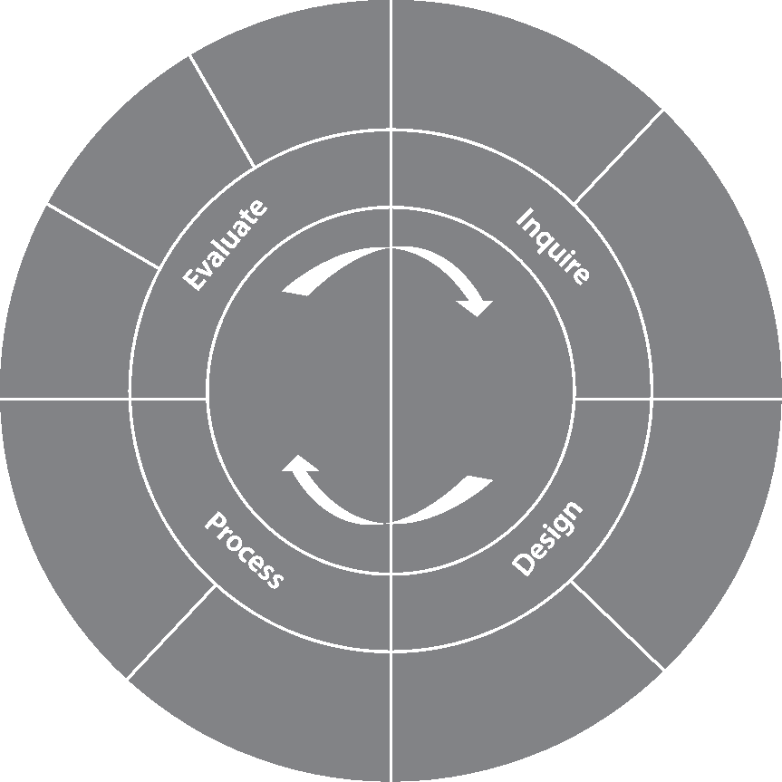
Evaluate the hypothesis
Interpret and
explain the
results
Evaluate the method
Collect, organize,
transform and present
data
Processing
and
evaluating
Discuss
improvements or
extensions to the
method
Inquiring
and
designing
Design a safe, logical and
Explain the
problem or
question to be
tested
complete method
Explain how to manipulate the variables and how data will be collected
Formulate and explain a testable hypothesis
The experimental cycle

Sciences in the MYP
Sciences guide 15
Interdisciplinary teaching and learning is grounded in individual subject groups and disciplines, but extends disciplinary understanding in ways that are:

Interdisciplinary learning
- integrative—bringing together concepts, methods or modes of communication from two or more subject groups, disciplines or established areas of expertise to develop new perspectives
- purposeful—connecting disciplines to solve real-world problems, create products or address complex issues in ways that would have been unlikely through a single approach.
Interdisciplinary teaching and learning builds a connected curriculum that addresses the developmental needs of students in the MYP. It prepares students for further academic (inter)disciplinary study and for life in an increasingly interconnected world.
The MYP uses concepts and contexts as starting points for meaningful integration and transfer of knowledge across subject groups and disciplines. Fostering interdisciplinary teaching and learning in the MYP (2014) contains more information, including a detailed process for planning and recording interdisciplinary units.
MYP schools are responsible for engaging students in at least one collaboratively planned interdisciplinary unit for each year of the programme.
MYP sciences offer many opportunities for interdisciplinary teaching and learning. Possible interdisciplinary units in this subject group could include inquiries into:
- using mathematics to interpret and present data
- designing lighting and sound for arts productions using quantitative analysis
- investigating the properties of materials for design projects.
Interdisciplinary learning can take place through large- and small-scale learning engagements. Authentic interdisciplinary learning often requires critical reflection and detailed collaborative planning. However, teachers and students can also make interdisciplinary connections through spontaneous learning experiences and conversations.
All MYP subject group teachers are responsible for developing meaningful ongoing opportunities for interdisciplinary teaching and learning.

Sciences in the MYP
16 Sciences guide
MYP projects

MYP projects
The MYP community project (for students in years 3 or 4) and MYP personal project (for students in year 5) aim to encourage and enable sustained inquiry within a global context that generates new insights and deeper understanding. In these culminating experiences, students develop confidence as principled, lifelong learners. They grow in their ability to consider their own learning, communicate effectively and take pride in their accomplishments.
Courses in sciences help students to develop key approaches to learning (ATL) that lead to success and enjoyment in the MYP projects. In this subject group, students have important opportunities to practise ATL skills, especially organizing and depicting information logically. Collaboration skills are an essential aspect of the scientific enterprise.
From their learning experiences in this subject group, students can find inspiration for their projects. Students’ interest in the natural world and in technological innovation provides many points of entry into projects that involve science, technology, engineering and mathematics.
MYP sciences offers many opportunities for learning through action. Inspiration from sciences for community projects and personal projects might include inquiries into:
- scientific principles and natural phenomena of personal interest
- applications of science to solve practical problems
- individual, community or global challenges that require scientific understanding
- scientific literacy in local and national communities
- the impact of scientific developments and innovations.

Written and taught curriculum
Sciences guide 17
Teaching hours

Requirements
Schools must allocate the teaching hours necessary to meet the requirements of MYP sciences.
The MYP requires at least 50 hours of teaching time for each subject group in each year of the programme.
In practice, more time is often necessary to meet subject group aims and objectives and to provide for the sustained, concurrent teaching that enables interdisciplinary study.
For students pursuing IB MYP course results that can contribute to the awarding of the IB MYP certificate, the recommended sciences courses should include at least 70 teaching hours in each of the final two years of the programme (MYP year 4 and MYP year 5).
Organizing sciences in the school
MYP sciences courses usually include biology, chemistry and physics, but schools may develop and offer other sciences courses as long as students can meet the aims and objectives of the IB subject group. Additional courses could include environmental sciences, life sciences, physical sciences, sport sciences, health sciences and earth sciences.
Although schools may vary the structure of the sciences curriculum throughout the five years of the programme, they should offer either discrete or modular science courses:
Discrete sciences courses generally encompass biology, chemistry and physics, but may include other science disciplines. Discrete science courses can include interdisciplinary science units that explore concepts, skills and processes from two or more science disciplines, provided that teachers
- use related concepts from the course’s disciplinary focus
- devote at least fifty per cent (50%) of guided learning hours in the course to its disciplinary focus.
Modular sciences courses include two or more discrete sciences taught in rotation. This structure can also include interdisciplinary science units, provided that schools
- clearly identify student achievement of MYP sciences objectives for each discipline
- provide a balanced selection of science disciplines.
In every year of MYP sciences, all students must independently complete a scientific investigation that is assessed against criterion B (inquiring and designing) and criterion C (processing and evaluating).

Written and taught curriculum
18 Sciences guide
IB World Schools are responsible for developing and structuring MYP sciences courses that provide opportunities for students to meet the aims and objectives of the programme. Each school’s circumstances, including local and national curriculum requirements, determine the organization of the sciences within the school.

Planning the sciences curriculum
MYP standards and practices require schools to facilitate and promote collaborative planning for the purpose of curriculum development and review.
Sciences objectives for years 1 to 5 of the curriculum provide continuity and outline a progression of learning. These objectives guide teachers in making decisions about developmentally appropriate learning experiences, including formative and summative assessments.
As they develop the vertical articulation of sciences over the years of the programme, teachers should plan increasingly complex units of work that encompass multiple objectives. However, within these units, discrete tasks or smaller units of work might concentrate on specific objectives or individual strands.
Sciences courses offer many opportunities to build interdisciplinary connections across the curriculum. Horizontal articulation for each year of the programme should coordinate teaching and learning across courses in sciences, as well as identify shared conceptual understandings and approaches to learning (ATL) that span multiple subject groups and help to create a coherent learning experience for students throughout the year.

Written and taught curriculum
Sciences guide 19
Inquiry, in the broadest sense, is the process that is used to move to deeper levels of understanding. Inquiry involves speculating, exploring, questioning and connecting. In all IB programmes, inquiry develops curiosity and promotes critical and creative thinking.

Teaching and learning through inquiry
The MYP structures sustained inquiry in sciences by developing conceptual understanding in global contexts. Teachers and students develop a statement of inquiry and use inquiry questions to explore the subject. Through their inquiry, students develop specific interdisciplinary and disciplinary approaches to learning skills.
Conceptual understanding
A concept is a “big idea”—a principle or notion that is enduring, the significance of which goes beyond particular origins, subject matter, or place in time. Concepts represent the vehicle for students’ inquiry into the issues and ideas of personal, local and global significance, providing the means by which they can explore the essence of the sciences.
Concepts have an important place in the structure of knowledge that requires students and teachers to think with increasing complexity as they organize and relate facts and topics.
Concepts express understanding that students take with them into lifelong adventures of learning. They help students to develop principles, generalizations and theories. Students use conceptual understanding as they solve problems, analyse issues, and evaluate decisions that can have an impact on themselves, their communities and the wider world.
In the MYP, conceptual understanding is framed by prescribed key and related concepts. Teachers must use these concepts to develop the curriculum. Schools may identify and develop additional concepts to meet local circumstances and curriculum requirements.
Key concepts
Key concepts promote the development of a broad curriculum. They represent big ideas that are both relevant within and across disciplines and subjects. Inquiry into key concepts can facilitate connections between and among:
- courses within the sciences subject group (intra-disciplinary learning)
- other subject groups (interdisciplinary learning).
Table 1 lists the key concepts to be explored across the MYP. The key concepts contributed by the study of sciences are change, relationships and systems.

Teaching and learning through inquiry
20 Sciences guide
Aesthetics | Change | Communication | Communities
Connections | Creativity | Culture | Development
Form | Global interactions | Identity | Logic
Perspective | Relationships | Systems | Time, place and space

Table 1
MYP key concepts
These key concepts provide a framework for sciences, informing units of work and helping to organize teaching and learning.
Change
Change is a conversion, transformation or movement from one form, state or value to another. Inquiry into the concept of change involves understanding and evaluating causes, processes and consequences.
In sciences, change is viewed as the difference in a system’s state when observed at different times. This change could be qualitative (such as differences in structure, behaviour, or level) or quantitative (such as a numerical variable or a rate). Change can be irreversible, reversible or self-perpetuating.
Relationships
Relationships are the connections and associations between properties, objects, people and ideas— including the human community’s connections with the world in which we live. Any change in relationship brings consequences—some of which may occur on a small scale, while others may be far reaching, affecting large networks and systems such as human societies and the planetary ecosystem.
Relationships in sciences indicate the connections found among variables through observation or experimentation. These relationships also can be tested through experimentation. Scientists often search for the connections between form and function. Modelling is also used to represent relationships where factors such as scale, volume of data, or time make other methods impractical.
Systems
Systems are sets of interacting or interdependent components. Systems provide structure and order in human, natural and built environments. Systems can be static or dynamic, simple or complex.
Systems in sciences describe sets of components that function due to their interdependence or complementary nature. Common systems in science are closed systems, where resources are not removed or replaced, and open systems, where necessary resources are renewed regularly. Modelling often uses closed systems to simplify or limit variables.
Other key concepts can also be important in sciences. For example, development is an important aspect in the continual growth through change that epitomizes scientific knowledge. Science offers important perspectives on the definition, measurement and meaning of time, place and space. Creativity is always important for scientists working together to extend the limits of human understanding.

Teaching and learning through inquiry
Sciences guide 21
Related concepts
Related concepts promote deep learning. They are grounded in specific disciplines and are useful for exploring key concepts in greater detail. Inquiry into related concepts helps students develop more complex and sophisticated conceptual understanding. Related concepts may arise from the subject matter of a unit or the craft of a subject—its features and processes.
The following tables list related concepts for the study of sciences. Teachers are not limited to the related concepts listed in this chart and may choose others when planning units, including from other subject groups.
Related concepts in biology
Balance | Development | Energy
Environment | Evidence | Form
Function | Interaction | Models
Movement | Patterns | Transformation

Table 2a
Related concepts in biology
Related concepts in chemistry
Balance | Conditions | Consequences
Energy | Evidence | Form
Function | Interaction | Models
Movement | Patterns | Transfer

Table 2b
Related concepts in chemistry
Related concepts in physics
Consequences | Development | Energy
Environment | Evidence | Form
Function | Interaction | Models
Movement | Patterns | Transformation

Table 2c
Related concepts in physics

Teaching and learning through inquiry
22 Sciences guide
 | Related concepts for modular sciences courses
Balance |  | Consequences | Energy
Environment |  | Evidence | Form
Function |  | Interaction | Models
Movement |  | Patterns | Transformation

Table 2d
Related concepts for modular sciences courses
The appendix contains a glossary of these related concepts for sciences.
Global contexts for teaching and learning
Global contexts direct learning toward independent and shared inquiry into our common humanity and shared guardianship of the planet. Using the world as the broadest context for learning, MYP sciences can develop meaningful explorations of
- identities and relationships
- orientation in space and time
- personal and cultural expression
- scientific and technical innovation
- globalization and sustainability
- fairness and development.
Teachers must identify a global context for teaching and learning, or develop additional contexts that help students explore the relevance of their inquiry (why it matters).

Many inquiries into sciences concepts naturally focus on scientific and technical innovation. However, courses in this subject group should, over time, offer students multiple opportunities to explore all MYP global contexts in relation to the aims and objectives of the subject group.
Statements of inquiry
Statements of inquiry set conceptual understanding in a global context in order to frame classroom inquiry and direct purposeful learning. Table 3 shows some possible statements of inquiry for possible units of work in MYP sciences.

Teaching and learning through inquiry
Sciences guide 23
Statement of inquiry | Key concept Related concepts Global context | Possible project/study
Scientific and technological advances enable societies to use, control and transform the function of organisms and biological molecules. | - Change  - Function, transformation  - Scientific and technical innovation | Biology: biotechnology
Models can represent the structural and functional relationship between DNA and inherited traits. | - Relationships  - Models, structure, function  - Identities and relationships | Biology: DNA and heredity
Organisms interact with the natural environment by  transferring matter and energy. | - Systems  - Interaction, environment, energy  - Scientific and technical innovation | Biology: ecology
Population change is a  consequence of the unbalanced opportunities provided by natural selection. | - Change  - Consequences, balance  - Fairness and development | Biology: evolution
A person’s health is influenced by cultural and conditional changes to diet. | - Change  - Influence, culture, conditions, balance  - Identities and relationships | Chemistry: food chemistry
Knowledge-challenging discoveries evolve the periodic table’s form to enhance its function of showing trends in the physical and chemical properties of the elements. | - Relationships  - Change, form, function  - Orientation in space and time | Chemistry: periodic trends
Scientists observe patterns and use them to construct systems that explain how the world works. | - Systems  - Patterns, development, models  - Personal and cultural expression | Chemistry: chemical nomenclature
Increasing electrical energy production to meet the needs of an expanding global population can have environmental consequences. | - Change  - Environment, consequences, development, energy  - Globalization and sustainability | Physics: magnetism and electricity

Teaching and learning through inquiry
24 Sciences guide
Statement of inquiry | Key concept Related concepts Global context | Possible project/study
Technological advances like nuclear energy affect the relationship between humans and the natural environment. | - Relationships  - Consequences, energy, evidence  - Scientific and technical innovation | Physics: nuclear energy
Technology designers creatively apply energy transformations in order to develop and reinvent devices. | - Systems  - Energy, transformation, development  - Scientific and technical innovation | Physics: application of physics

Table 3
Example statements of inquiry
Inquiry questions
Teachers and students use statements of inquiry to help them identify factual, conceptual and debatable inquiry questions. Inquiry questions give direction to teaching and learning, and they help to organize and sequence learning experiences.
Table 4 shows some possible inquiry questions for MYP sciences units.
Factual questions:  Remembering facts and topics |  |  | Conceptual questions:  Analysing big ideas |  | Debatable questions:  Evaluating perspectives and  developing theories
• | What do cells look like? | • | How is the universe | • | Who should have the
• | How do scientists measure |  | structured? |  | power to modify and
 | chemical molecules and | • | How do models evolve |  | control genetic material?
 | compounds? |  | and transform? | • | What are the social and
• | Which technologies are  available for producing | • | What is the relationship  between microbiology |  | economic consequences of nuclear energy?
 | electrical energy at an industrial scale? |  | and natural selection? | • | What are the limits of scientific understanding?

Table 4
Examples of factual, conceptual and debatable questions
Approaches to learning
All MYP units of work offer opportunities for students to develop and practise approaches to learning (ATL) skills. These skills provide valuable support for students working to meet the subject group’s aims and objectives.

Teaching and learning through inquiry
Sciences guide 25
ATL skills are grouped into five categories that span the IB continuum of international education. IB programmes identify discrete skills in each category that can be introduced, practised and consolidated in the classroom and beyond.
While ATL skills are relevant across all MYP subject groups, teachers may also identify ATL skill indicators especially relevant for, or unique to, a particular subject group or course.
Table 5 suggests some of the indicators that can be important in sciences.
Category | Skill indicator
Thinking skills | Interpret data gained from scientific investigations.
Social skills | Practise giving feedback on the design of experimental methods.
Communication skills | Use appropriate visual representations of data based on purpose and audience.
Self-management skills | Structure information appropriately in laboratory investigation reports.
Research skills | Make connections between scientific research and related moral, ethical, social, economic, political, cultural or environmental factors.

Table 5
Examples of sciences-specific skill indicators
Well-designed learning engagements and assessments provide rich opportunities for students to practise and demonstrate ATL skills. Each MYP unit explicitly identifies ATL skills around which teaching and learning can focus, and through which students can authentically demonstrate what they are able to do. Formative assessments provide important feedback for developing discrete skills, and many ATL skills support students as they demonstrate their achievements in summative assessments of subject group objectives.
Table 6 lists some specific ATL skills that students can demonstrate through performances of understanding in sciences.
Approaches to learning
Thinking (or critical thinking): Draw justifiable conclusions based on processing, interpreting and evaluating data gained from scientific investigations.

Communication (or interaction): Use appropriate scientific terminology, data tables and graphs to make the meaning of your findings clear to an audience of your peers.
Table 6
Examples of sciences demonstrations of ATL skills

Written and taught curriculum
26 Sciences guide
Mathematical requirements

Subject-specific guidance
Throughout the MYP sciences students should have regular exposure to the mathematical skills developed in MYP mathematics and used by scientists. By the end of the MYP sciences course, students should be able to:
- perform the basic arithmetic functions: addition, subtraction, multiplication and division
- use calculations involving means, decimals, fractions, percentages, ratios, approximations and reciprocals
- use standard notation (for example, 3.6 × 10⁶)
- use direct and inverse proportion
- solve simple algebraic equations
- solve linear simultaneous equations
- plot graphs (with suitable scales and axes), including two variables that show linear and non-linear relationships
- interpret graphs, including the significance of gradients, changes in gradients, intercepts and areas
- draw lines (either curves or linear) of best fit on a scatter plot graph
- interpret data presented in various forms (for example, bar charts, histograms and pie charts)
- represent arithmetic mean using x-bar notation (for example, X )
Safety in practical work
Because IB science courses emphasize inquiry and experimentation, schools need to provide many field experiences and laboratory work for students. Schools should follow these guidelines to help ensure safety in practical work.
- Assess and manage the risk of potential hazards
- Maintain school science laboratories and ensure that they are safe and well equipped
- Ensure that everyone involved in practical work knows the correct safety codes and procedures to follow
- Use appropriate class size and supervision of practical work to limit potential risks and hazards
It is a basic responsibility of everyone involved in MYP sciences to make safety and health an ongoing commitment within the context of local requirements, educational and cultural traditions, financial constraints and national legal systems. Teachers can use these guidelines developed by the International Council of Associations for Science Education (ICASE) Safety Committee by The Laboratory Safety Institute (LSI).

Subject-specific guidance
Sciences guide 27
The Laboratory Safety Institute’s Laboratory Safety Guidelines 40 suggestions for a safer lab
Steps requiring minimal expense
- Have a written health, safety and environmental affairs (HS&E) policy statement.
- Organize a departmental HS&E committee of employees, management, faculty, staff and students that will meet regularly to discuss HS&E issues.
- Develop an HS&E orientation for all new employees and students.
- Encourage employees and students to care about their health and safety and that of others.
- Involve every employee and student in some aspect of the safety programme and give each specific responsibilities.
- Provide incentives to employees and students for safety performance.
- Require all employees to read the appropriate safety manual. Require students to read the institution’s laboratory safety rules. Have both groups sign a statement that they have done so, understand the contents, and agree to follow the procedures and practices. Keep these statements on file in the department office.
- Conduct periodic, unannounced laboratory inspections to identify and correct hazardous conditions and unsafe practices. Involve students and employees in simulated health and safety inspections.
- Make learning how to be safe an integral and important part of science education, your work and your life.
- Schedule regular departmental safety meetings for all students and employees to discuss the results of inspections and aspects of laboratory safety.
- When conducting experiments with hazards or potential hazards, ask yourself these questions.
– What are the hazards?
– What are the worst possible things that could go wrong?
– How will I deal with them?
– What are the prudent practices, protective facilities and equipment necessary to minimize the
risk of exposure to the hazards?
- Require that all accidents (incidents) be reported, evaluated by the departmental safety committee, and discussed at departmental safety meetings.
- Require every pre-lab/pre-experiment discussion to include consideration of the health and safety aspects.
- Don’t allow experiments to run unattended unless they are failsafe.
- Forbid working alone in any laboratory and working without the prior knowledge of a staff member.
- Extend the safety programme beyond the laboratory to the automobile and the home.
- Allow only minimum amounts of flammable liquids in each laboratory.
- Forbid smoking, eating and drinking in the laboratory.
- Do not allow food to be stored in chemical refrigerators.
- Develop plans and conduct drills for dealing with emergencies such as fire, explosion, poisoning, chemical spill or vapour release, electric shock, bleeding and personal contamination.
- Require good housekeeping practices in all work areas.

Subject-specific guidance
28 Sciences guide
- Display the phone numbers of the fire department, police department and local ambulance either on or immediately next to every phone.
- Store acids and bases separately. Store fuels and oxidizers separately.
- Maintain a chemical inventory to avoid purchasing unnecessary quantities of chemicals.
- Use warning signs to designate particular hazards.
- Develop specific work practices for individual experiments, such as those that should be conducted only in a ventilated hood or involve particularly hazardous materials. Whenever possible, most hazardous experiments should be done in a hood.
Steps requiring moderate expense
- Allocate a portion of the departmental budget to safety.
- Require the use of appropriate eye protection at all times in laboratories and areas where chemicals are transported.
- Provide adequate supplies of personal protective equipment—safety glasses, goggles, face shields, gloves, lab coats and bench-top shields.
- Provide fire extinguishers, safety showers, eye wash fountains, first aid kits, fire blankets and fume hoods in each laboratory and test or check monthly.
- Provide guards on all vacuum pumps and secure all compressed gas cylinders.
- Provide an appropriate supply of first-aid equipment and instruction on its proper use.
- Provide fireproof cabinets for storage of flammable chemicals.
- Maintain a centrally located departmental safety library.
- Remove all electrical connections from inside chemical refrigerators and require magnetic closures.
- Require grounded plugs on all electrical equipment and install ground fault interrupters (GFIs), where appropriate.
- Label all chemicals to show the name of the material, the nature and degree of hazard, the appropriate precautions, and the name of the person responsible for the container.
- Develop a programme for dating stored chemicals and for recertifying or discarding them after predetermined maximum periods of storage.
- Develop a system for the legal, safe and ecologically acceptable disposal of chemical wastes.
- Provide secure, adequately spaced, well-ventilated storage of chemicals.

Assessed curriculum
In the MYP, assessment is closely aligned with the written and taught curriculum. Each strand from MYP sciences has a corresponding strand in the assessment criteria for this subject group. Figure 5 illustrates this alignment and the increasingly complex demands for student performance at higher achievement levels.

Alignment of objectives and assessment criteria

C Processing and evaluating
At the end of year 5, students should be able to:
i. present collected and
transformed data
- interpret data and explain results using scientific reasoning
- evaluate the validity of a hypothesis based on the outcome of the scientific investigation
- evaluate the validity of the method
- explain improvements or extensions to the method.
Achievement  level |  | Level descriptor
0 |  | The student does not reach a standard identified by any of the descriptors below.
 | 1–2 | The student is able to:
 |  | i. collect and present data in numerical and/or visual forms
- interpret data
- state the validity of a hypothesis based on the outcome of a scientific investigation
- state the validity of the method based on the outcome of a scientific investigation
- state improvements or extensions to the method.
 | 3–4 | The student is able to:
i. correctly collect and present data in numerical and/or
visual forms
- accurately interpret data and explain results
- outline the validity of a hypothesis based on the outcome of a scientific investigation
- outline the validity of the method based on the outcome of a scientific investigation
- outline improvements or extensions to the method that would benefit the scientific investigation.
 | 5–6 | The student is able to:
 |  | i. correctly collect, organize and present data in numerical
 |  | and/or visual forms
- accurately interpret data and explain results using scientific reasoning
- discuss the validity of a hypothesis based on the outcome of a scientific investigation
- discuss the validity of the method based on the outcome of a scientific investigation
- describe improvements or extensions to the method that would benefit the scientific investigation.
 | 7–8 | The student is able to:
i. correctly collect, organize, transform and present data in
numerical and/or visual forms
- accurately interpret data and explain results using correct scientific reasoning
- evaluate the validity of a hypothesis based on the outcome of a scientific investigation
- evaluate the validity of the method based on the outcome of a scientific investigation
- explain improvements or extensions to the method that would benefit the scientific investigation.

Figure 5
Sciences guide 29
Sciences objectives and criteria alignment

Assessed curriculum
30 Sciences guide
Assessment for sciences courses in all years of the programme is criterion-related, based on four equally weighted assessment criteria:

Assessment criteria overview
Criterion A | Knowing and understanding | Maximum 8
Criterion B | Inquiring and designing | Maximum 8
Criterion C | Processing and evaluating | Maximum 8
Criterion D | Reflecting on the impacts of science | Maximum 8

Subject groups must assess all strands of all four assessment criteria at least twice in each year of the MYP.
In the MYP, subject group objectives correspond to assessment criteria. Each criterion has eight possible achievement levels (1–8), divided into four bands that generally represent limited (1–2); adequate (3–4); substantial (5–6); and excellent (7–8) performance. Each band has its own unique descriptor that teachers use to make “best-fit” judgments about students’ progress and achievement.
This guide provides the required assessment criteria for years 1, 3 and 5 of MYP sciences. In response to national or local requirements, schools may add criteria and use additional models of assessment. Schools must use the appropriate assessment criteria as published in this guide to report students’ final achievement in the programme.
Teachers clarify the expectations for each summative assessment task with direct reference to these assessment criteria. Task-specific clarifications should clearly explain what students are expected to know and do. They could be in the form of:
- a task-specific version of the required assessment criteria
- a face-to-face or virtual classroom discussion
- a detailed task sheet or assignment.

Assessed curriculum
Sciences guide 31
Criterion A: Knowing and understanding

Sciences assessment criteria: Year 1
Maximum: 8
At the end of year 1, students should be able to:
- outline scientific knowledge
- apply scientific knowledge and understanding to solve problems set in familiar situations and suggest solutions to problems set in unfamiliar situations
- interpret information to make scientifically supported judgments.
Achievement  level | Level descriptor
0 | The student does not reach a standard described by any of the descriptors below.
1–2 | The student is able to:  - select scientific knowledge  - select scientific knowledge and understanding to suggest solutions to problems set in familiar situations  - apply information to make judgments, with limited success.
3–4 | The student is able to:  - recall scientific knowledge  - apply scientific knowledge and understanding to suggest solutions to problems set in familiar situations  - apply information to make judgments.
5–6 | The student is able to:  - state scientific knowledge  - apply scientific knowledge and understanding to solve problems set in familiar situations  - apply information to make scientifically supported judgments.
7–8 | The student is able to:  - outline scientific knowledge  - apply scientific knowledge and understanding to solve problems set in familiar situations and suggest solutions to problems set in unfamiliar situations  - interpret information to make scientifically supported judgments.

Sciences assessment criteria: Year 1
32 Sciences guide
Criterion B: Inquiring and designing
Maximum: 8
At the end of year 1, students should be able to:
- outline an appropriate problem or research question to be tested by a scientific investigation
- outline a testable prediction using scientific reasoning
- outline how to manipulate the variables, and outline how data will be collected
- design scientific investigations.
Achievement  level | Level descriptor
0 | The student does not reach a standard described by any of the descriptors below.
1–2 | The student is able to:  - select a problem or question to be tested by a scientific investigation  - select a testable prediction  - state a variable  - design a method with limited success.
3–4 | The student is able to:  - state a problem or question to be tested by a scientific investigation  - state a testable prediction  - state how to manipulate the variables, and state how data will be collected  - design a safe method in which he or she selects materials and equipment.
5–6 | The student is able to:  - state a problem or question to be tested by a scientific investigation  - outline a testable prediction  - outline how to manipulate the variables, and state how relevant data will be collected  - design a complete and safe method in which he or she selects appropriate materials and equipment.
7–8 | The student is able to:  - outline a problem or question to be tested by a scientific investigation  - outline a testable prediction using scientific reasoning  - outline how to manipulate the variables, and outline how sufficient, relevant data will be collected  - design a logical, complete and safe method in which he or she selects appropriate materials and equipment.

Sciences assessment criteria: Year 1
Sciences guide 33
Criterion C: Processing and evaluating
Maximum: 8
At the end of year 1, students should be able to:
- present collected and transformed data
- interpret data and outline results using scientific reasoning
- discuss the validity of a prediction based on the outcome of the scientific investigation
- discuss the validity of the method
- describe improvements or extensions to the method.
Achievement  level | Level descriptor
0 | The student does not reach a standard described by any of the descriptors below.
1–2 | The student is able to:  - collect and present data in numerical and/or visual forms  - interpret data  - state the validity of a prediction based on the outcome of a scientific investigation, with limited success  - state the validity of the method based on the outcome of a scientific investigation, with limited success  - state improvements or extensions to the method that would benefit the scientific investigation, with limited success.
3–4 | The student is able to:  - correctly collect and present data in numerical and/or visual forms  - accurately interpret data and outline results  - state the validity of a prediction based on the outcome of a scientific investigation  - state the validity of the method based on the outcome of a scientific investigation  - state improvements or extensions to the method that would benefit the scientific investigation.
5–6 | The student is able to:  - correctly collect, organize and present data in numerical and/or visual forms  - accurately interpret data and outline results using scientific reasoning  - outline the validity of a prediction based on the outcome of a scientific investigation  - outline the validity of the method based on the outcome of a scientific investigation  - outline improvements or extensions to the method that would benefit the scientific investigation.

Sciences assessment criteria: Year 1
34 Sciences guide
Achievement  level | Level descriptor
7–8 | The student is able to:  - correctly collect, organize, transform and present data in numerical and/ or visual forms  - accurately interpret data and outline results using correct scientific reasoning  - discuss the validity of a prediction based on the outcome of a scientific investigation  - discuss the validity of the method based on the outcome of a scientific investigation  - describe improvements or extensions to the method that would benefit the scientific investigation.

Sciences assessment criteria: Year 1
Sciences guide 35
Criterion D: Reflecting on the impacts of science
Maximum: 8
At the end of year 1, students should be able to:
- summarize the ways in which science is applied and used to address a specific problem or issue
- describe and summarize the various implications of using science and its application in solving a specific problem or issue
- apply scientific language effectively
- document the work of others and sources of information used.
Achievement  level | Level descriptor
0 | The student does not reach a standard described by any of the descriptors below.
1–2 | The student is able to, with limited success:  - state the ways in which science is used to address a specific problem or issue  - state the implications of using science to solve a specific problem or issue, interacting with a factor  - apply scientific language to communicate understanding  - document sources.
3–4 | The student is able to:  - state the ways in which science is used to address a specific problem or issue  - state the implications of using science to solve a specific problem or issue, interacting with a factor  - sometimes apply scientific language to communicate understanding  - sometimes document sources correctly.
5–6 | The student is able to:  - outline the ways in which science is used to address a specific problem or issue  - outline the implications of using science to solve a specific problem or issue, interacting with a factor  - usually apply scientific language to communicate understanding clearly and precisely  - usually document sources correctly.
7–8 | The student is able to:  - summarize the ways in which science is applied and used to address a specific problem or issue  - describe and summarize the implications of using science and its application to solve a specific problem or issue, interacting with a factor  - consistently apply scientific language to communicate understanding clearly and precisely  - document sources completely.

Assessed curriculum
36 Sciences guide
Criterion A: Knowing and understanding

Sciences assessment criteria: Year 3
Maximum: 8
At the end of year 3, students should be able to:
- describe scientific knowledge
- apply scientific knowledge and understanding to solve problems set in familiar and unfamiliar situations
- analyse information to make scientifically supported judgments.
Achievement  level | Level descriptor
0 | The student does not reach a standard indicated by any of the descriptors below.
1–2 | The student is able to:  - recall scientific knowledge  - apply scientific knowledge and understanding to suggest solutions to problems set in familiar situations  - apply information to make judgments.
3–4 | The student is able to:  - state scientific knowledge  - apply scientific knowledge and understanding to solve problems set in familiar situations  - apply information to make scientifically supported judgments.
5–6 | The student is able to:  - outline scientific knowledge  - apply scientific knowledge and understanding to solve problems set in familiar situations and suggest solutions to problems set in unfamiliar situations  - interpret information to make scientifically supported judgments.
7–8 | The student is able to:  - describe scientific knowledge  - apply scientific knowledge and understanding to solve problems set in familiar and unfamiliar situations  - analyse information to make scientifically supported judgments.

Sciences assessment criteria: Year 3
Sciences guide 37
Criterion B: Inquiring and designing
Maximum: 8
At the end of year 3, students should be able to:
- describe a problem or question to be tested by a scientific investigation
- outline a testable hypothesis and explain it using scientific reasoning
- describe how to manipulate the variables, and describe how data will be collected
- design scientific investigations.
Achievement  level | Level descriptor
0 | The student does not reach a standard identified by any of the descriptors below.
1–2 | The student is able to:  - state a problem or question to be tested by a scientific investigation, with limited success  - state a testable hypothesis  - state the variables  - design a method, with limited success.
3–4 | The student is able to:  - state a problem or question to be tested by a scientific investigation  - outline a testable hypothesis using scientific reasoning  - outline how to manipulate the variables, and state how relevant data will be collected  - design a safe method in which he or she selects materials and equipment.
5–6 | The student is able to:  - outline a problem or question to be tested by a scientific investigation  - outline and explain a testable hypothesis using scientific reasoning  - outline how to manipulate the variables, and outline how sufficient, relevant data will be collected  - design a complete and safe method in which he or she selects appropriate materials and equipment.
7–8 | The student is able to:  - describe a problem or question to be tested by a scientific investigation  - outline and explain a testable hypothesis using correct scientific reasoning  - describe how to manipulate the variables, and describe how sufficient, relevant data will be collected  - design a logical, complete and safe method in which he or she selects appropriate materials and equipment.

Sciences assessment criteria: Year 3
38 Sciences guide
Criterion C: Processing and evaluating
Maximum: 8
At the end of year 3, students should be able to:
- present collected and transformed data
- interpret data and describe results using scientific reasoning
- discuss the validity of a hypothesis based on the outcome of the scientific investigation
- discuss the validity of the method
- describe improvements or extensions to the method.
Achievement  level | Level descriptor
0 | The student does not reach a standard identified by any of the descriptors below.
1–2 | The student is able to:  - collect and present data in numerical and/or visual forms  - accurately interpret data  - state the validity of a hypothesis with limited reference to a scientific investigation  - state the validity of the method with limited reference to a scientific investigation  - state limited improvements or extensions to the method.
3–4 | The student is able to:  - correctly collect and present data in numerical and/or visual forms  - accurately interpret data and describe results  - state the validity of a hypothesis based on the outcome of a scientific investigation  - state the validity of the method based on the outcome of a scientific investigation  - state improvements or extensions to the method that would benefit the scientific investigation.
5–6 | The student is able to:  - correctly collect, organize and present data in numerical and/or visual forms  - accurately interpret data and describe results using scientific reasoning  - outline the validity of a hypothesis based on the outcome of a scientific investigation  - outline the validity of the method based on the outcome of a scientific investigation  - outline improvements or extensions to the method that would benefit the scientific investigation.

Sciences assessment criteria: Year 3
Sciences guide 39
Achievement  level | Level descriptor
7–8 | The student is able to:  - correctly collect, organize, transform and present data in numerical and/ or visual forms  - accurately interpret data and describe results using correct scientific reasoning  - discuss the validity of a hypothesis based on the outcome of a scientific investigation  - discuss the validity of the method based on the outcome of a scientific investigation  - describe improvements or extensions to the method that would benefit the scientific investigation.

Sciences assessment criteria: Year 3
40 Sciences guide
Criterion D: Reflecting on the impacts of science
Maximum: 8
At the end of year 3, students should be able to:
- describe the ways in which science is applied and used to address a specific problem or issue
- discuss and analyse the various implications of using science and its application in solving a specific problem or issue
- apply scientific language effectively
- document the work of others and sources of information used.
Achievement  level | Level descriptor
0 | The student does not reach a standard identified by any of the descriptors below.
1–2 | The student is able to:  - state the ways in which science is used to address a specific problem or issue  - state the implications of the use of science to solve a specific problem or issue, interacting with a factor  - apply scientific language to communicate understanding but does so with limited success  - document sources, with limited success.
3–4 | The student is able to:  - outline the ways in which science is used to address a specific problem or issue  - outline the implications of using science to solve a specific problem or issue, interacting with a factor  - sometimes apply scientific language to communicate understanding  - sometimes document sources correctly.
5–6 | The student is able to:  - summarize the ways in which science is applied and used to address a specific problem or issue  - describe the implications of using science and its application to solve a specific problem or issue, interacting with a factor  - usually apply scientific language to communicate understanding clearly and precisely  - usually document sources correctly.

Sciences assessment criteria: Year 3
Sciences guide 41
Achievement  level | Level descriptor
7–8 | The student is able to:  - describe the ways in which science is applied and used to address a specific problem or issue  - discuss and analyse the implications of using science and its application to solve a specific problem or issue, interacting with a factor  - consistently apply scientific language to communicate understanding clearly and precisely  - document sources completely.

Assessed curriculum
42 Sciences guide
Criterion A: Knowing and understanding

Sciences assessment criteria: Year 5
Maximum: 8
At the end of year 5, students should be able to:
- explain scientific knowledge
- apply scientific knowledge and understanding to solve problems set in familiar and unfamiliar situations
- analyse and evaluate information to make scientifically supported judgments.
Achievement  level | Level descriptor
0 | The student does not reach a standard identified by any of the descriptors below.
1–2 | The student is able to:  - state scientific knowledge  - apply scientific knowledge and understanding to suggest solutions to problems set in familiar situations  - interpret information to make judgments.
3–4 | The student is able to:  - outline scientific knowledge  - apply scientific knowledge and understanding to solve problems set in familiar situations  - interpret information to make scientifically supported judgments.
5–6 | The student is able to:  - describe scientific knowledge  - apply scientific knowledge and understanding to solve problems set in familiar situations and suggest solutions to problems set in unfamiliar situations  - analyse information to make scientifically supported judgments.
7–8 | The student is able to:  - explain scientific knowledge  - apply scientific knowledge and understanding to solve problems set in familiar and unfamiliar situations  - analyse and evaluate information to make scientifically supported judgments.

Sciences assessment criteria: Year 5
Sciences guide 43
Criterion B: Inquiring and designing
Maximum: 8
At the end of year 5, students should be able to:
- explain a problem or question to be tested by a scientific investigation
- formulate a testable hypothesis and explain it using scientific reasoning
- explain how to manipulate the variables, and explain how data will be collected
- design scientific investigations.
Achievement  level | Level descriptor
0 | The student does not reach a standard identified by any of the descriptors below.
1–2 | The student is able to:  - state a problem or question to be tested by a scientific investigation  - outline a testable hypothesis  - outline the variables  - design a method, with limited success.
3–4 | The student is able to:  - outline a problem or question to be tested by a scientific investigation  - formulate a testable hypothesis using scientific reasoning  - outline how to manipulate the variables, and outline how relevant data will be collected  - design a safe method in which he or she selects materials and equipment.
5–6 | The student is able to:  - describe a problem or question to be tested by a scientific investigation  - formulate and explain a testable hypothesis using scientific reasoning  - describe how to manipulate the variables, and describe how sufficient, relevant data will be collected  - design a complete and safe method in which he or she selects appropriate materials and equipment.
7–8 | The student is able to:  - explain a problem or question to be tested by a scientific investigation  - formulate and explain a testable hypothesis using correct scientific reasoning  - explain how to manipulate the variables, and explain how sufficient, relevant data will be collected  - design a logical, complete and safe method in which he or she selects appropriate materials and equipment.

Sciences assessment criteria: Year 5
44 Sciences guide
Criterion C: Processing and evaluating
Maximum: 8
At the end of year 5, students should be able to:
- present collected and transformed data
- interpret data and explain results using scientific reasoning
- evaluate the validity of a hypothesis based on the outcome of the scientific investigation
- evaluate the validity of the method
- explain improvements or extensions to the method.
Achievement  level | Level descriptor
0 | The student does not reach a standard identified by any of the descriptors below.
1–2 | The student is able to:  - collect and present data in numerical and/or visual forms  - interpret data  - state the validity of a hypothesis based on the outcome of a scientific investigation  - state the validity of the method based on the outcome of a scientific investigation  - state improvements or extensions to the method.
3–4 | The student is able to:  - correctly collect and present data in numerical and/or visual forms  - accurately interpret data and explain results  - outline the validity of a hypothesis based on the outcome of a scientific investigation  - outline the validity of the method based on the outcome of a scientific investigation  - outline improvements or extensions to the method that would benefit the scientific investigation.
5–6 | The student is able to:  - correctly collect, organize and present data in numerical and/or visual forms  - accurately interpret data and explain results using scientific reasoning  - discuss the validity of a hypothesis based on the outcome of a scientific investigation  - discuss the validity of the method based on the outcome of a scientific investigation  - describe improvements or extensions to the method that would benefit the scientific investigation.

Sciences assessment criteria: Year 5
Sciences guide 45
Achievement  level | Level descriptor
7–8 | The student is able to:  - correctly collect, organize, transform and present data in numerical and/ or visual forms  - accurately interpret data and explain results using correct scientific reasoning  - evaluate the validity of a hypothesis based on the outcome of a scientific investigation  - evaluate the validity of the method based on the outcome of a scientific investigation  - explain improvements or extensions to the method that would benefit the scientific investigation.

Sciences assessment criteria: Year 5
46 Sciences guide
Criterion D: Reflecting on the impacts of science
Maximum: 8
At the end of year 5, students should be able to:
- explain the ways in which science is applied and used to address a specific problem or issue
- discuss and evaluate the various implications of using science and its application to solve a specific problem or issue
- apply scientific language effectively
- document the work of others and sources of information used.
Achievement  level | Level descriptor
0 | The student does not reach a standard identified by any of the descriptors below.
1–2 | The student is able to:  - outline the ways in which science is used to address a specific problem or issue  - outline the implications of using science to solve a specific problem or issue, interacting with a factor  - apply scientific language to communicate understanding but does so with limited success  - document sources, with limited success.
3–4 | The student is able to:  - summarize the ways in which science is applied and used to address a specific problem or issue  - describe the implications of using science and its application to solve a specific problem or issue, interacting with a factor  - sometimes apply scientific language to communicate understanding  - sometimes document sources correctly.
5–6 | The student is able to:  - describe the ways in which science is applied and used to address a specific problem or issue  - discuss the implications of using science and its application to solve a specific problem or issue, interacting with a factor  - usually apply scientific language to communicate understanding clearly and precisely  - usually document sources correctly.

Sciences assessment criteria: Year 5
Sciences guide 47
Achievement  level | Level descriptor
7–8 | The student is able to:  - explain the ways in which science is applied and used to address a specific problem or issue  - discuss and evaluate the implications of using science and its application to solve a specific problem or issue, interacting with a factor  - consistently apply scientific language to communicate understanding clearly and precisely  - document sources completely.

Assessed curriculum
48 Sciences guide
Students seeking IB MYP course results for MYP sciences complete an on-screen examination in which they can demonstrate their achievement of subject group objectives. Successful results can contribute to students’ attainment of the IB MYP certificate.

eAssessment
This verification of learning assures accurate and consistently applied standards, as set forth in the Guide to MYP eAssessment.

Appendices
Sciences guide 49

Related concepts in sciences
Related concept | Definition
Balance: biology specific | The dynamic equilibrium that exists among members of a stable natural community; the regulation of the internal environment of an organism.
Balance: chemistry specific | A state of equilibrium or stable distribution.
Conditions: chemistry specific | The environment, both physical and chemical, of a reaction or process; factors which contribute to an interaction including temperature, pressure, concentration, pH and the absence or presence of a catalyst.
Consequences | The observable or quantifiable effects, results, or outcomes correlated with an earlier event or events.
Development: physics specific | The process of applying theory to data and observations in order to improve, progress, or further scientific understanding.
Energy | The capacity of an object to do work or transfer heat.
Environment: biology specific | All of the biotic and abiotic factors that act on an organism, population or community and influence its survival, evolution and development.
Environment: physics specific | A description of the universe or a closed system through the application of the laws of physics; the complex of physical conditions or climate affecting a habitat or community.
Evidence | Support for a proposition derived from observation and interpretation of data.
Form | The features of an object that can be observed, identified, described, classified and categorized.
Function | A purpose, a role or a way of behaving that can be investigated; a mathematical relationship between variables.
Interaction | The effect or effects two or more systems, bodies, substances or organisms have on one another, so that the overall result is not simply the sum of the separate effects.
Models | Representations used for testing scientific theories or proposals that can be accurately repeated and validated; simulations used for explaining or predicting processes which may not be observable or to understand the dynamics of multiple underlying phenomena of a complex system.
Movement | The act, process, or result of displacing from one location or position to another within a defined frame of reference.
Patterns | The distribution of variables in time or space; sequences of events or features.

Related concepts in sciences
50 Sciences guide
Related concept | Definition
Transfer: chemistry specific | The net movement of matter or particles from one location to another.
Transformation: biology specific | Differentiation of a cell; change of energy form, including at a molecular level; alteration of molecules and metabolism and/or genetic make-up of an organism or species and consequently a community, relative to external factors.
Transformation: physics specific | A change from one well-defined state to another well-defined state; an alteration in form or condition, including energy and particle nature.

Appendices
Sciences guide 51

Sciences glossary
Term | Definition
Cultural | Patterns of knowledge, behaviour, beliefs, shared attitudes, values, goals and practices that characterize groups of people.
Data | Measurement of a parameter that can be quantitative (volume, temperature, pH and so on) or qualitative (colour, shape, texture and so on).
Dependent variable | The variable in which values are measured in the experiment.
Economic | Production, distribution, and use of income, wealth, and commodities.
Environmental | Circumstances, objects, or conditions by which one is surrounded.
Ethical | Process of rational inquiry to decide on issues as right or wrong, as applied to the people and their actions.
Extensions to the method | Developments for further inquiry as related to the outcome of the investigation.
Hypothesis | A tentative explanation for an observation or phenomenon that requires experimental confirmation; can take the form of a question or a statement.
Independent variable | The variable that is selected and manipulated by the investigator in an experiment.
Moral | Principles of right or wrong behaviour derived from a particular society.
Numerical forms | May include mathematical calculations such as averaging or determining values from a graph or table.
Political | Relates to government or public affairs.
Prediction | Give an expected result of an upcoming action or event.
Qualitative data | Refers to non-numerical data or information that is difficult to measure in a numerical way.
Quantitative data | Refers to numerical measurements of the variables associated with the investigation.
Social | Interactions between groups of people involving issues such as welfare, safety, rights, justice or class.

Sciences glossary
52 Sciences guide
Term | Definition
Transforming data | Involves processing raw data into a form suitable for visual representation. This process may involve, for example, combining and manipulating raw data (by adding, subtracting, squaring or dividing) to determine the value of a physical quantity and also taking the average of several measurements. It might be that the data collected are already in a form suitable for visual representationin the case of the distance travelled by a woodlouse, for example. If the raw data are represented in this way and a best-fit line graph is drawn the raw data have been processed.
Unfamiliar situation | Refers to a problem or situation in which the context or the application is modified so that it is considered unfamiliar for the student.
Validity of the method | Refers to whether the method allows for the collection of sufficient valid data to answer the question. This includes factors such as whether the measuring instrument measures what it is supposed to measure, the conditions of the experiment and the manipulation of variables (fair testing).
Visual forms | May include drawing graphs of various types appropriate to the kind of data being displayed (for example, line graphs, bar graphs, histograms or pie charts).

Appendices
Sciences guide 53

MYP command terms for sciences
Command term | Definition
Analyse | Break down in order to bring out the essential elements or structure. (To identify parts and relationships, and to interpret information to reach conclusions.)
Annotate | Add brief notes to a diagram or graph.
Apply | Use knowledge and understanding in response to a given situation or real circumstances. Use an idea, equation, principle, theory or law in relation to a given problem or issue.
Calculate | Obtain a numerical answer showing the relevant stages in the working.
Classify | Arrange or order by class or category.
Comment | Give a judgment based on a given statement or result of a calculation.
Construct | Display information in a diagrammatic or logical form.
Define | Give the precise meaning of a word, phrase, concept or physical quantity.
Demonstrate | Make clear by reasoning or evidence, illustrating with examples or practical application.
Describe | Give a detailed account or picture of a situation, event, pattern or process.
Design | Produce a plan, simulation or model.
Determine | Obtain the only possible answer.
Discuss | Offer a considered and balanced review that includes a range of arguments, factors or hypotheses. Opinions or conclusions should be presented clearly and supported by appropriate evidence.
Document | Credit sources of information used by referencing (or citing), following one recognized referencing system. References should be included in the text and also at the end of the piece of work in a reference list or bibliography.
Draw | Represent by means of a labelled, accurate diagram or graph, using a pencil. A ruler (straight edge) should be used for straight lines. Diagrams should be drawn to scale. Graphs should have points correctly plotted (if appropriate) and joined in a straight line or smooth curve.
Estimate | Obtain an approximate value for an unknown quantity.
Evaluate | Make an appraisal by weighing up the strengths and limitations.
Explain | Give a detailed account including reasons and causes. (See also “Justify”.)
Find | Obtain an answer showing relevant stages in the working.

Sciences glossary
54 Sciences guide
Formulate | Express precisely and systematically the relevant concept(s) or argument(s).
Identify | Provide an answer from a number of possibilities. Recognize and state briefly a distinguishing fact or feature.
Interpret | Use knowledge and understanding to recognize trends and draw conclusions from given information.
Justify | Give valid reasons or evidence to support an answer or conclusion. (See also “Explain”).
Label | Add title, labels or brief explanation(s) to a diagram or graph.
List | Give a sequence of brief answers with no explanation.
Measure | Obtain a value for a quantity.
Organize | Put ideas and information into a proper or systematic order.
Outline | Give a brief account or summary.
Plot | Mark the position of points on a diagram.
Present | Offer for display, observation, examination or consideration.
Recall | Remember or recognize from prior learning experiences.
Select | Choose from a list or group.
Show | Give the steps in a calculation or derivation.
Sketch | Represent by means of a diagram or graph (labelled as appropriate). The sketch should give a general idea of the required shape or relationship, and should include relevant features.
Solve | Obtain the answer(s) using appropriate methods.
State | Give a specific name, value or other brief answer without explanation or calculation.
Suggest | Propose a solution, hypothesis or other possible answer.
Summarize | Abstract a general theme or major point(s).
Verify | Provide evidence that validates the result.
Write down | Obtain the answer(s), usually by extracting information. Little or no calculation is required. Working does not need to be shown.

Appendices
Sciences guide 55
Fensham, P. 2011. “Knowledge to deal with challenges to science education from without and within”. In Corrigan, D, Dillon, J and Gunstone, R, The Professional Knowledge Base of Science Teaching. Monash University, Melbourne, Australia. Springer.

Selected reading
Kuhlthau, C. 2010. “Guided inquiry: school libraries in the 21st century”. School Libraries Worldwide. Vol 16, number 1. Pp 17−28.
Rhoton, J. 2010. Science Education Leadership: Best Practices for the New Century. Arlington, Virginia, USA. National Science Teachers Association Press.
Simon, HA. 1996. “Observations on the sciences of science learning”. Paper prepared for the Committee on Developments in the Science of Learning for the Sciences of Science Learning: An Interdisciplinary Discussion. Department of Psychology, Carnegie Mellon University.
Wright, T and Hamilton, S. 2009. Assessing student understanding in the molecular life using a concept inventory. Queensland, Australia. The University of Queensland.
Laboratory safety resources
Wood, C. 1994. “Safety in School Science Labs”. Wellesley, USA. Kaufman & Associates.
The Laboratory Safety Pocket Guide. Genium Publishing Corporation. 1996. New York, USA.
Safety in Academic Chemistry Laboratories. American Chemical Society. 2003. Washington DC, USA.
“Manual of Safety and Health Hazards in the School Science Laboratory”. Council of State Science Supervisors. The Laboratory Safety Institute. Massachusetts, USA.
“Safety in the School Science Laboratory”. Council of State Science Supervisors. The Laboratory Safety Institute. Massachusetts, USA.
“School Science Laboratories: A guide to Some Hazardous Substances”. Council of State Science Supervisors. The Laboratory Safety Institute. Massachusetts, USA.
Handbook of Laboratory Safety. 4th Edition. CRC Press. 2000. Boca Raton, USA.
Fire Protection Guide on Hazardous Materials. National Fire Protection Association. 2010. Massachusetts, USA.
National Research Council. 1995. Prudent Practices in the Laboratory: Handling and Disposal of Hazardous Chemicals. 2nd edition. CRC Press. Boca Raton, USA.
“Biosafety in the Laboratory”. The National Academies Press. 1989. Washington DC, USA.
“Learning By Accident”. Volumes 1–3. 1997–2000. The Laboratory Safety Institute. Massachusetts, USA.

